**R. Turton, J. A. Shaeiwitz, D. Bhattacharyya, & W. B. Whiting’s *Analysis, Synthesis, and Design of Chemical Processes*, 5th Edition, Prentice Hall, 2018.**

**Appendix C.4: The Design of a New 100,000-Metric-Tons-per-Year Phthalic Anhydride Production Facility**

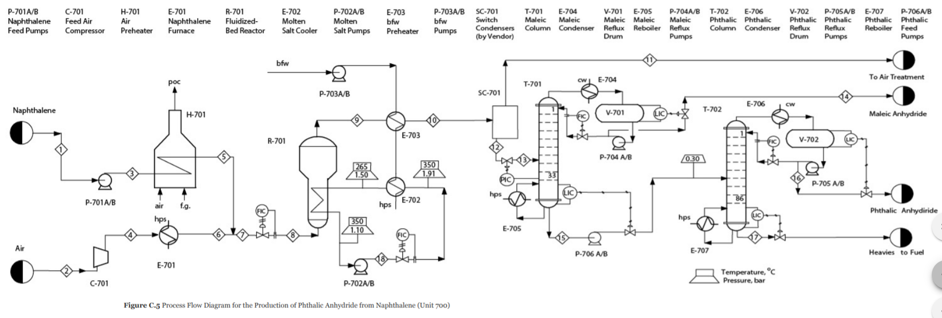

**C.4.1 BACKGROUND**

The operation of Unit 700, our phthalic anhydride facility, has been successfully scaled down by 50%. Over the long term, changing to o-xylene as the raw material is still being considered. The catalysis and reaction engineering group has finished preliminary research and is very optimistic about its new catalyst. They promise that it will be superior to other versions of o-xylene to phthalic anhydride catalysts in that most side products are minimized. At this point it is unclear whether Unit 700 will be retrofitted to accommodate the new catalyst or whether a new, grassroots facility will be built at another site, nearer to an o-xylene producer.

In order to have enough information to make an informed decision, a preliminary process design is needed for a grassroots facility to produce phthalic anhydride from what may be assumed to be pure o-xylene. The assignment is to prepare a preliminary design for the new 100,000 tonne/y phthalic anhydride from o-xylene plant, and it must be completed within the next month. It may assumed that the o-xylene feed is available at 100°C and 1.1 bar and that the required purity for phthalic and maleic anhydride products is 99.9 wt% and 95.0 wt%, respectively.

Molecular weight phthalic anhydride = 148.10 g/mol

Molecular weight maleic anhydride = 98.06 g/mol

**C.4.2 OTHER INFORMATION**

Concentrated organic waste streams may be burned instead of natural gas only if a fired heater is included in the design. Dilute organic waste streams must be sent to a treatment facility, with the appropriate operating cost charged. The capital cost of this facility may be assumed to be included in the grassroots cost of the new facility. Other pertinent information is given in Tables C.11, C.12, and C.13.

The catalysis and reaction engineering group has obtained the following kinetic information regarding the o-xylene to phthalic anhydride reaction. The reactions are

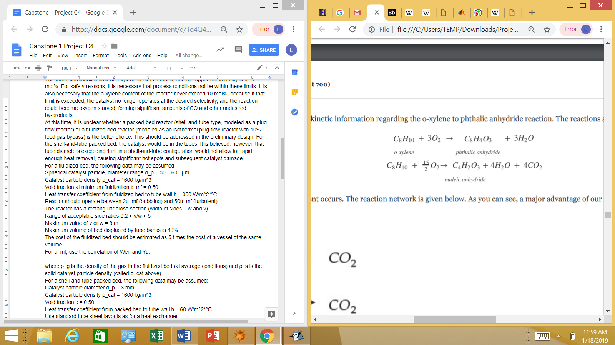

In addition, the complete combustion reaction for each organic component occurs. The reaction network is given below. As you can see, a major advantage of our catalyst is that CO formation is essentially eliminated and no heavy impurity is made.

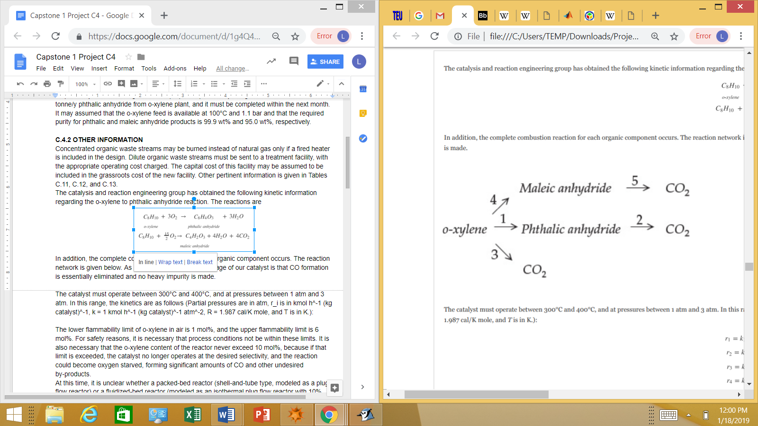

The catalyst must operate between 300°C and 400°C, and at pressures between 1 atm and 3 atm. In this range, the kinetics are as follows (Partial pressures are in atm, r_i is in kmol h^-1 (kg catalyst)^-1, k_0 = 1 kmol h^-1 (kg catalyst)^-1 atm^-2, R = 1.987 cal/K mole, and T is in K.):

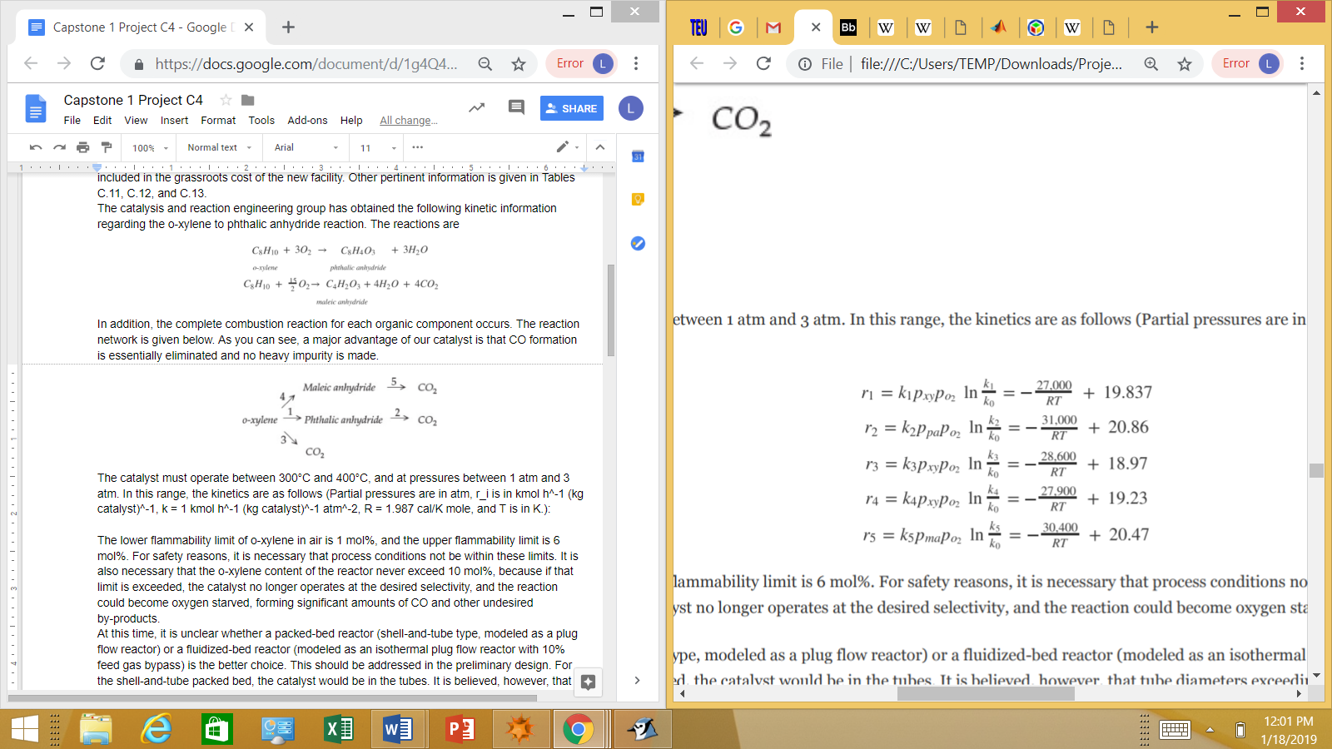

The lower flammability limit of o-xylene in air is 1 mol%, and the upper flammability limit is 6 mol%. For safety reasons, it is necessary that process conditions not be within these limits. It is also necessary that the o-xylene content of the reactor never exceed 10 mol%, because if that limit is exceeded, the catalyst no longer operates at the desired selectivity, and the reaction could become oxygen starved, forming significant amounts of CO and other undesired by-products.

At this time, it is unclear whether a packed-bed reactor (shell-and-tube type, modeled as a plug flow reactor) or a fluidized-bed reactor (modeled as an isothermal plug flow reactor with 10% feed gas bypass) is the better choice. This should be addressed in the preliminary design.

No need to test; can reference literature instead - <https://scholarsmine.mst.edu/cgi/viewcontent.cgi?article=7969&context=masters_theses>

For the shell-and-tube packed bed, the catalyst would be in the tubes. It is believed, however, that tube diameters exceeding 1 in. in a shell-and-tube configuration would not allow for rapid enough heat removal, causing significant hot spots and subsequent catalyst damage.

**For a fluidized bed, the following data may be assumed:**

Spherical catalyst particle, diameter range d_p = 300–600 μm

Catalyst particle density ρ_cat = 1600 kg/m^3

Void fraction at minimum fluidization ε_mf = 0.50

Heat transfer coefficient from fluidized bed to tube wall h = 300 W/m^2*°C

Reactor should operate between 2u_mf (bubbling) and 50u_mf (turbulent)

The reactor has a rectangular cross section (width of sides = w and v)

Range of acceptable side ratios 0.2 < v/w < 5

Maximum value of v or w = 8 m

Maximum volume of bed displaced by tube banks is 40%

The cost of the fluidized bed should be estimated as 5 times the cost of a vessel of the same volume

For u_mf, use the correlation of Wen and Yu:

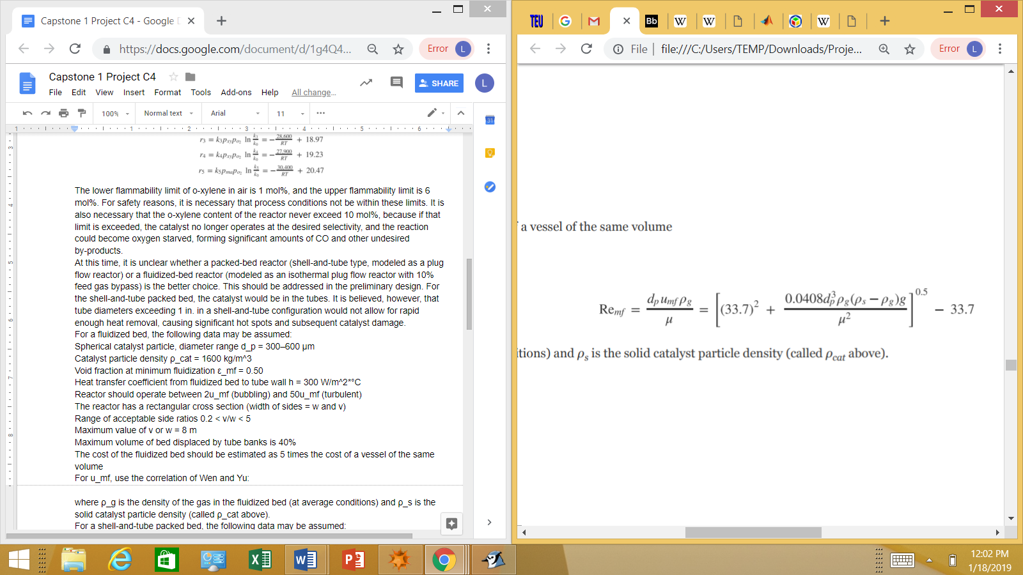

where ρ_g is the density of the gas in the fluidized bed (at average conditions) and ρ_s is the solid catalyst particle density (called ρ_cat above).

**For a shell-and-tube packed bed, the following data may be assumed:**

Catalyst particle diameter d_p = 3 mm

Catalyst particle density ρ_cat = 1600 kg/m^3

Void fraction ε = 0.50

Heat transfer coefficient from packed bed to tube wall h = 60 W/m^2*°C

Use standard tube sheet layouts as for a heat exchanger

Shell diameter is a function of heat transfer characteristics and frictional losses

It is anticipated that a heat transfer fluid will be used in a closed loop to remove the highly exothermic heat of reaction from either type of reactor. We anticipate that all surplus high-pressure steam made can be sold elsewhere in the plant. Because we have had many years of successful operation using the HiTec molten salt, we anticipate using it again for the new process. However, recommendations to use an alternative justified by superior performance at the same cost, or equal performance at a lower cost may be made.

The equipment for the switch condensers comprises a complex set of three condensers. Because of the low partial pressure of phthalic anhydride in the stream, it desublimates rather than condenses. Therefore, the process stream is cooled using a low-temperature oil in tubes to promote desublimation. Then, after solid is loaded on the heat transfer surface, gas flow to this condenser is stopped, and higher-temperature oil is circulated in the tubes to melt the solid. There are three such devices, one operating in desublimation mode, one operating in melting mode, and one on standby. The net result is a liquid stream containing the condensables and a vapor stream containing some maleic anhydride, some phthalic anhydride, and all of the noncondensables.

These condensers will once again be designed and maintained under contract by CONDENSEX. They indicate that operation at any scale is possible as long as the pressure of the feed to the condensers is between 1.70 and 2.00 bar. It may assumed that all light gases are neither condensed nor dissolved and that 99% of the organics are desublimated and melted. Based on past experience, CONDENSEX suggests that the capital cost of these condensers may be estimated as 15% of all other capital costs for the new process, and that the annual operating cost is 3 times the cost of an equivalent amount of cooling water needed to satisfy the cooling duty from the energy balance on the condenser unit modeled as a component separator.

The following cost of treating the waste (dirty) air stream leaving the switch condensers should be used in the cost estimates:

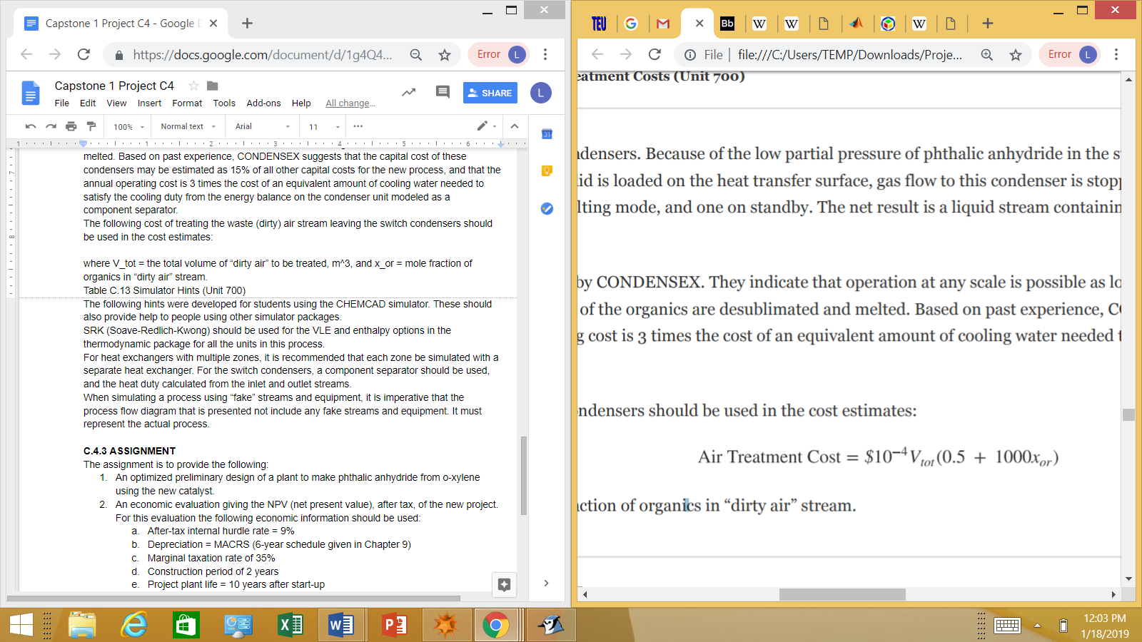

where V_tot = the total volume of “dirty air” to be treated, m^3, and x_or = mole fraction of organics in “dirty air” stream.

Table C.13 Simulator Hints (Unit 700)

The following hints were developed for students using the CHEMCAD simulator. These should also provide help to people using other simulator packages.

SRK (Soave-Redlich-Kwong) should be used for the VLE and enthalpy options in the thermodynamic package for all the units in this process.

For heat exchangers with multiple zones, it is recommended that each zone be simulated with a separate heat exchanger. For the switch condensers, a component separator should be used, and the heat duty calculated from the inlet and outlet streams.

When simulating a process using “fake” streams and equipment, it is imperative that the process flow diagram that is presented not include any fake streams and equipment. It must represent the actual process.

**C.4.3 ASSIGNMENT**

The assignment is to provide the following:

1. An optimized preliminary design of a plant to make phthalic anhydride from o-xylene using the new catalyst.
2. An economic evaluation giving the NPV (net present value), after tax, of the new project. For this evaluation the following economic information should be used:
   1. After-tax internal hurdle rate = 9%
   2. Depreciation = MACRS (6-year schedule given in Chapter 9)
   3. Marginal taxation rate of 35%
   4. Construction period of 2 years
   5. Project plant life = 10 years after start-up

Specifically, the following is to be prepared by ... (four weeks from now):

1. A written report detailing the design and profitability evaluation of the new process
2. A clear, complete, labeled process flow diagram of the optimized process
3. A clear stream flow table giving the T, P, total flowrate in kg/h and kmol/h, component flowrate in kmol/h, and phase for each important process stream
4. A list of new equipment to be purchased, including size, cost, and materials of construction
5. An evaluation of the after-tax NPV, and the discounted cash flow rate of return on investment (DCFROR) for the recommended (optimized) process
6. A legible, organized set of calculations justifying the recommendations, including any assumptions made

**C.4.4 REPORT FORMAT**

This report should be in the standard design report format. It should include an abstract, results, discussion, conclusions, recommendations, and an appendix with calculations. The report format rules given in Chapter 29 should be followed.